Florida International University

Project #1
Basic Circuit
EML 4804 Introduction to Mechatronics

Submitted By:
Elyion Clyburn
PID 6410764
Date of submission:
09/07/2025

Fall, 2025
Introduction
The purpose of this project is to learn how to build simple circuits by using the Raspberry PICO board, power supplies and simple electronic components to test an idea created from a model.
Materials used
- Breadboard
- Raspberry PICO board
- Power module and LiPo battery in the holder or USB cable
- Red LED
- resistor 220 Ohm
- resistor 10 kOhm
- resistor 100 kOhm
- tactile switch
- 4 x 10 mF electrolytic capacitors
- Wires

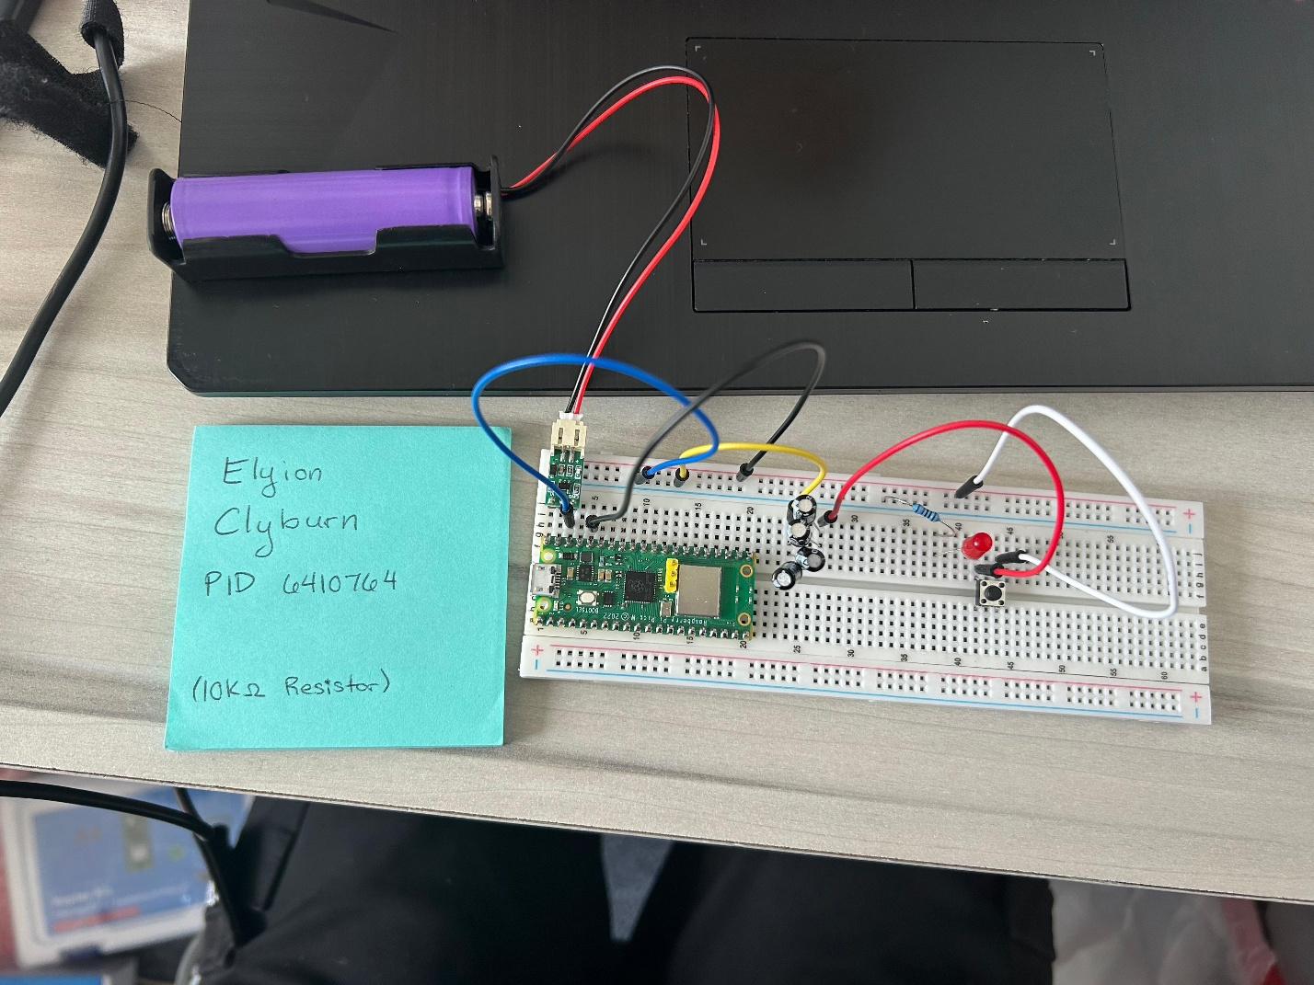
Picture
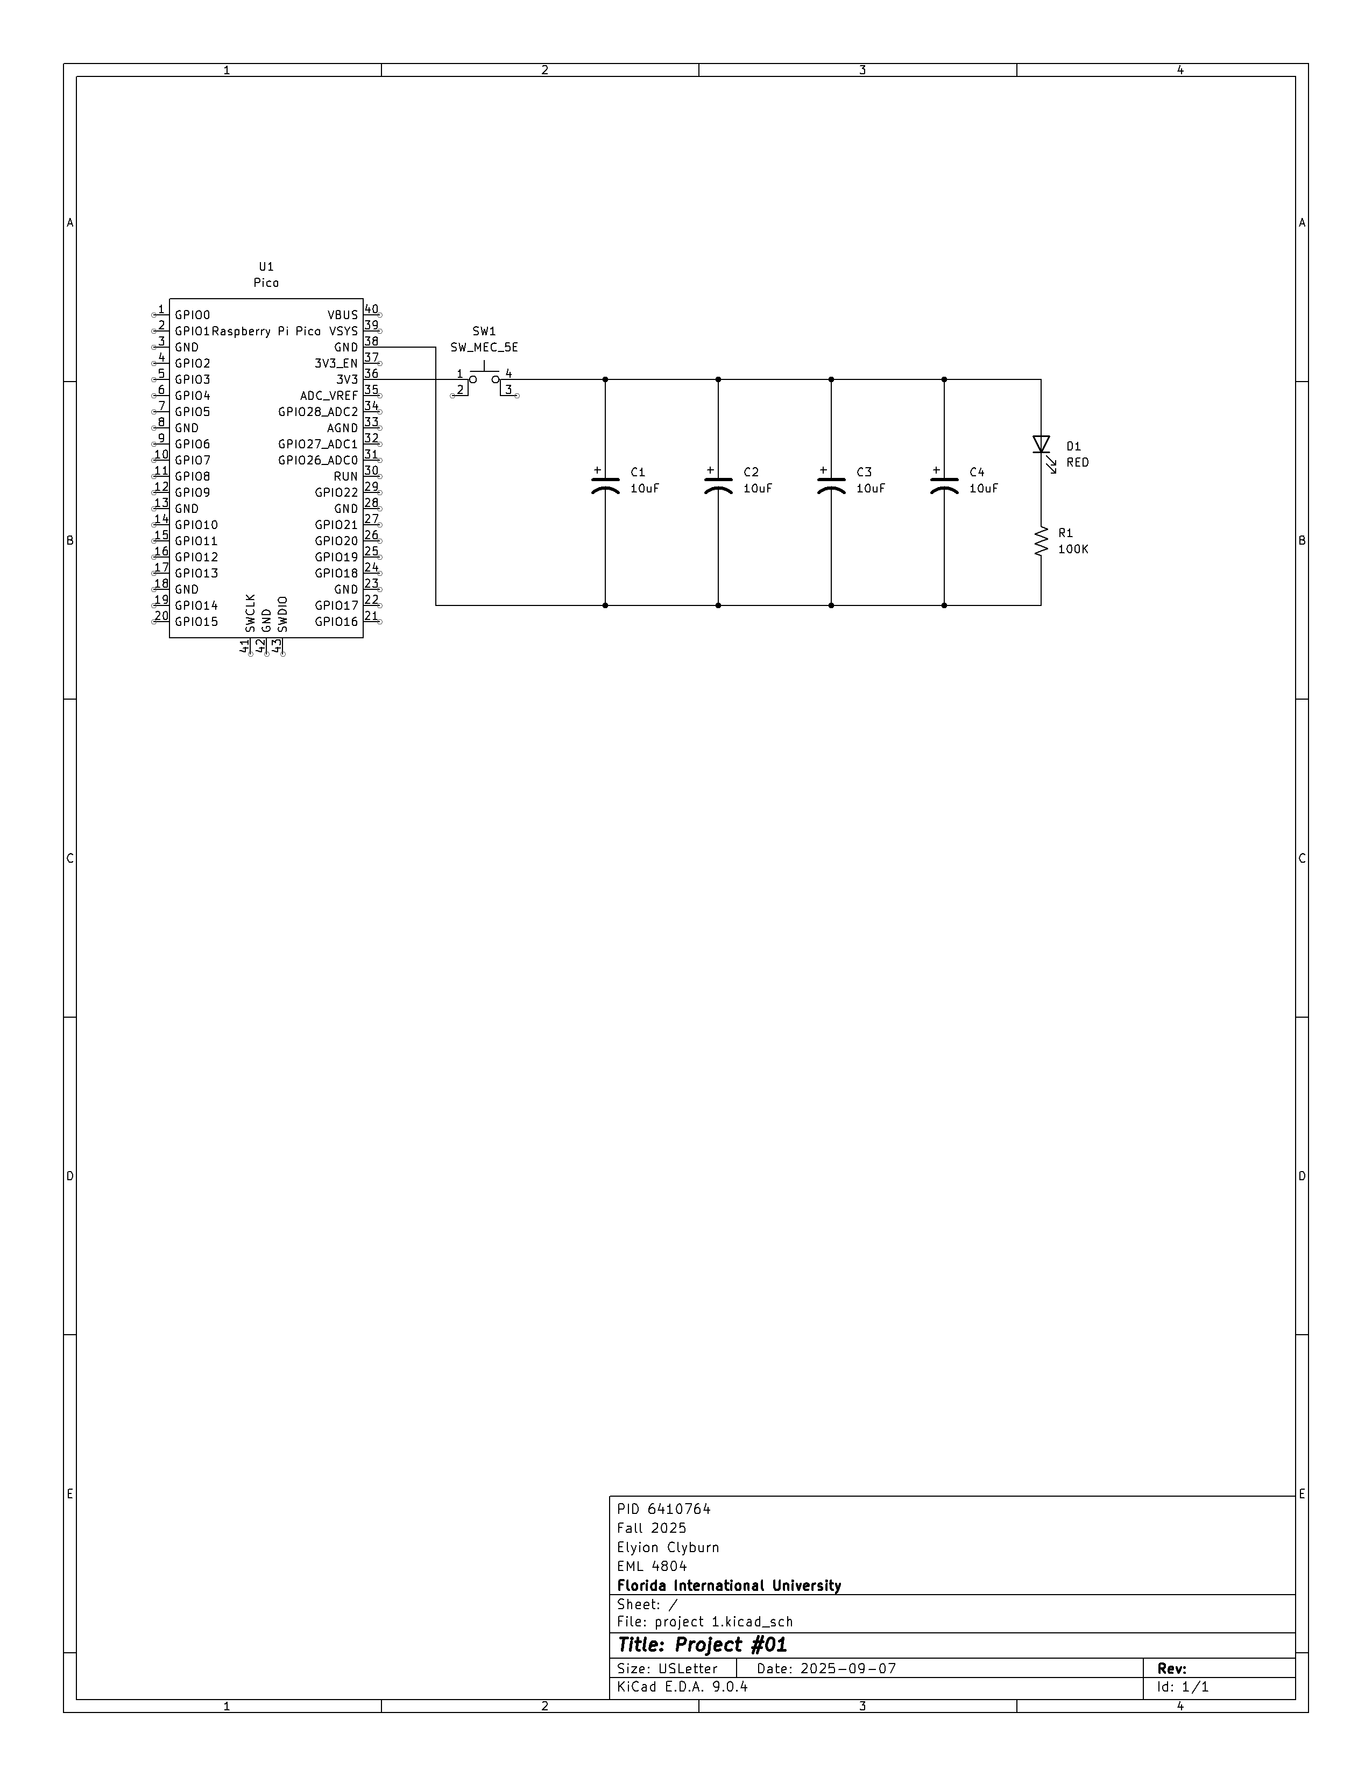
Video Link
https://youtu.be/jmQDxbgHbuQ
Data
Number of 10uF capacitors | Resistor value | Approximate decay time (s) | Brightness notes
4 | 220 Ω | 0.26 | Surprisingly bright
4 | 10 kΩ | 1.8 | Noticeably bright
4 | 100 kΩ | 10.55 | Barely noticeable
3 | 220 Ω | 0.59 | Surprisingly bright
3 | 10 kΩ | 1.55 | Noticeably bright
3 | 100 kΩ | 5.73 | Barely noticeable
2 | 220 Ω | 0.14 | Surprisingly bright
2 | 10 kΩ | 0.86 | Noticeably bright
2 | 100 kΩ | 3.85 | Barely noticeable
1 | 220 Ω | 0.18 | Surprisingly bright
1 | 10 kΩ | 0.58 | Noticeably bright
1 | 100 kΩ | 2.31 | Barely noticeable
0 | 220 Ω | 0.14 | Surprisingly bright
0 | 10 kΩ | 0.13 | Noticeably bright
0 | 100 kΩ | 0.13 | Barely noticeable

Conclusion
- What have you learned?
From this assignment, I learned how to create and read electrical schematics (better), and how to carefully create a simple circuit from mentioned schematics.
- How difficult was this assignment?
This assignment was not too difficult, maybe 4/10. I say this because I took a while to understand fully the flow of electricity in the circuit I was building compared to the schematic because the application looks a bit more confusing than the diagram.
- How did you overcome challenges?
To overcome my lack of complete understanding of the application to the circuit diagram, I rearranged the components on my breadboard and then cross-checked with the example video and my diagram to make sure the electricity was still flowing where I wanted it to.

References
Andriy Durygin. September 6, 2024. YouTube. Mechatronics with PICO | KiCAD basics.

